EXPERIMENT NO - 2
AIM: Linux shell scripts.
TOOLS/SOFTWARES REQUIRED: Linux OS
THEORY:
In this experiment we take a look at creating shell scripts on Linux. A shell script is a plain text file containing a sequence of commands for a Unix-based operating system (like Linux or macOS). It acts as a "to-do list" for your computer, allowing you to automate repetitive tasks by running one file instead of typing commands individually.
How to Create and Run a Script:
- Write the script: Use a text editor like Vim, Nano, or VS Code to create a file, typically ending in .sh.
- Make it executable: Use the command chmod +x your_script.sh to give yourself permission to run the file.
- Execute: Run it from the terminal by typing ./your_script.sh.

OUTPUT:
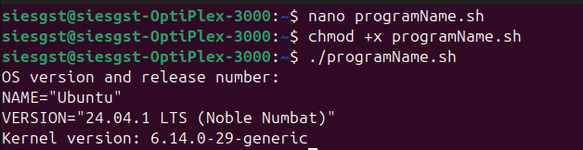
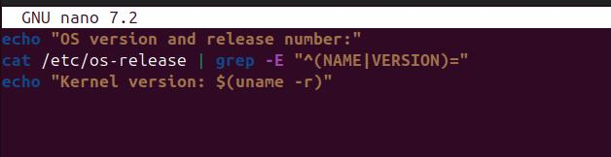
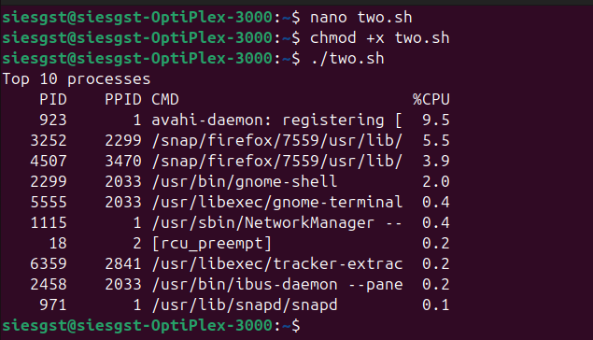
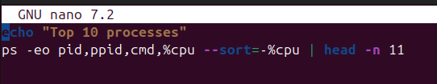
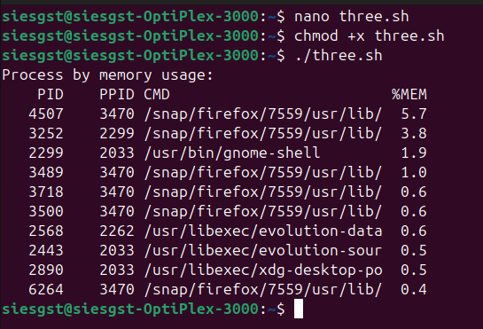
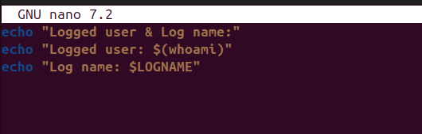
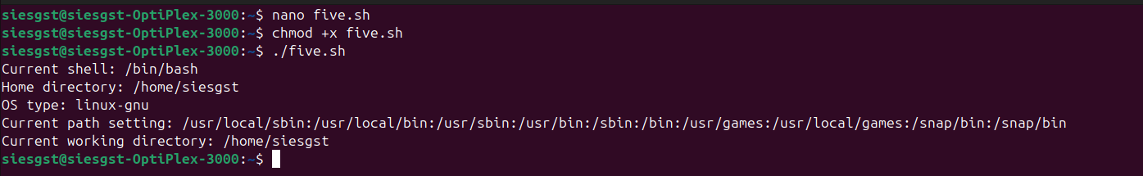
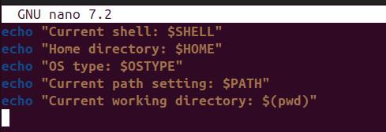

CONCLUSION: Hence, we have looked at how to write shell scripts within Ubuntu Linux OS and use it to run multiple shell commands easily and efficiently.

